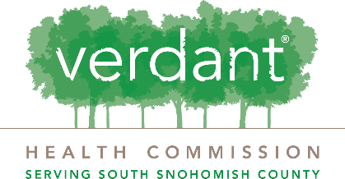
Grant Application
Narrative Questions
- What is the community need for this project? Be as specific as possible using local statistics and agency information to show the need.

- How does this program directly impact Verdant’s priority areas?

- Who will be served by this program? Explain how this program serves residents of South Snohomish County and what your current strategies are/ will be to recruit participants?

- How does this program demonstrate equity, diversity, and inclusion? How will the population(s) you intend to serve be involved in program development, delivery, and evaluation? How are the program/ organization staff reflective of the population(s) you intend to serve?

- Who are other organizations that offer similar services to this program? How will you collaborate with them and how is your program distinct?

- In addition to completing the outcomes section below, what is the anticipated impact of this program and what is your strategy for successful achievement and measurement of your included outcomes?

- Who are key partners that will support this program and their roles?

- How will this program be staffed and what is the organization capacity to support this program? What previous success has your organization had with delivering the services in the program?

- In addition to completing the budget form below, what are the proposed use of funds, including other sources of funds or resources, allocated to this program and your sustainability plan?

