Verdant Health Commission

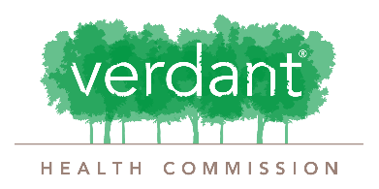
PROGRAM COMMITTEE
2021 concept paper

Organization Name:
Name of Project and Program:
Date of Project:
Name of Contact Person:
Contact Person E-mail:
Contact Person Phone:
Report Date:

Process:
Thank you for your interest in emergency COVID funding from the Verdant Health Commission! We are accepting concept papers from organizations doing work in response to COVID19 in support of the residents of our service area (the cities of Brier, Edmonds, Lynnwood, Mountlake Terrace, Woodway, and portions of Bothell and unincorporated Snohomish County).
Please complete the following information and submit to Zoe Reese, Director of Community Impact and Grantmaking at zoe.reese@verdanthealth.org.
Submissions are reviewed by staff when received and you can generally expect an email response regarding next steps within 10 business days.

Overview

Program/ Project Summary (Provide a general overview of the program/ project):

Community Impact (Why is there a need for this project and how does that need relate to the COVID-19 pandemic?):

Project Budget:
Please include total project budget below and indicate what additional funding or in-kind support has already been secured and what you are seeking Verdant to fund. Feel free to paste in your own budget format, an example is provided below.
Example:
Expenses: | Items | Verdant Request | Total Budget
Personnel Expenses:
Direct Project Expenses
Administrative Expenses
Subcontractual Expenses
Other Expenses
Total Project Budget:
Other Source of Funding (Specify)
Other Source of Funding (Specify)
Other Source of Funding (Specify)
Other Source of Funding (Specify)
In Kind Support Funding (Specify)
Misc. Funding (Specify)
Total Verdant Request
% of Project Funded by Verdant

Outcomes (what measurable outcomes will you track and report to demonstrate success):
Metric | Goal
Number of People Served:
Outcome 1 (Specify):
Outcome 2 (Specify):
Outcome 3 (Specify):
Outcome 4 (Specify):
Outcome 5 (Specify):
Outcome 6 (Specify)

Potential Partners and Roles (Please state the key partners who will support this program or project and their roles):

Proposed Project Time Period (start and end date):

Approval and Authority to Proceed
We have reviewed the proposal and approve proceeding to contract:

Lisa Edwards, Superintendent Date

