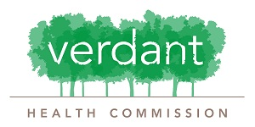
Verdant Community Wellness Center
Demonstration Kitchen Facility Request Form (WC 200) accompany a Facility Request Form (WC 100)

EVENT DATE: |  |  |  |  |  |  |  |  |  |  | TODAY’S DATE:
APPLICANT/ORGANIZATION:
EVENT CONTACT:
EMAIL: |  |  |  |  |  |  |  |  |  | PHONE:
EVENT NAME:
EVENT PURPOSE/DESCRIPTION:
TARGET AUDIENCE:
INSTRUCTOR: |  |  |  |  |  |  |  |  | QUALIFICATIONS:
BRIEFLY DESCRIBE THE FOOD PRODUCT(S) YOU PLAN TO PREPARE IN THE DEMO KITCHEN:
DO YOU PLAN TO HAVE AUDIENCE PARTICIPATION? Yes ☐ No ☐ If yes, describe how they will be involved:
WHAT EQUIPMENT WILL YOU REQUIRE TO PREPARE YOUR FOOD/S? (see Attachment 4 for a list of kitchen supplies)

Fees listed in the WC 100 form will apply to kitchen use, including damage deposits and the requirement to have liability insurance coverage.

